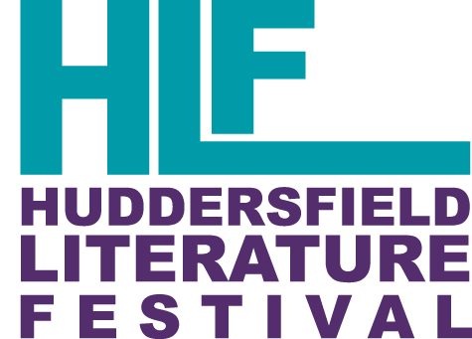

Ticket Types
Concession tickets can be purchased by those over 60 or under 16 (please note U16s should be accompanied by an adult); students in full-time education, anyone registered disabled, those receiving job seekers allowance, and Kirklees Passport holders.

Students and tutors at the University of Huddersfield can access free tickets to certain events, please see individual events for a list of these.

Ticket Transfer
If you know someone who can attend the event in your place you may transfer the ticket to them at no additional cost. Please email info@huddlitfest.org.uk if you would like to do this.

Refunds
Please note that refunds can only be issued if you cancel your booking at least 28 days before the event. Refunds will not be issued after this time. Refunds will not be issued after an event has taken place, as such, failure to attend an event will not be considered for refunds.

The only exception may be at the Festival’s discretion if an event is sold out and we are able to resell the tickets, to make such a request, email info@huddlitfest.org.uk.

Cancellation by Us
Cancellation may be necessary in exceptional circumstances and Huddersfield Literature Festival reserves the right in its absolute discretion to cancel an event. If this happens you will be offered a full and prompt refund of all monies you have paid. We will endeavour to notify you as soon as possible of any cancellation using the details you have during your original booking. If you do not receive this notification because you have not provided a correct email address, we cannot be held liable. Please also note, if cancellation of an event occurs, we are unable to offer any compensation, and cannot be responsible for any costs or expenses incurred by as a result.

Complaints
If you have a complaint please email us in the first instance at info@huddlitfest.org.uk and provide your name, contact number and details of the complaint and we will respond to you as soon as we are able. We do our best to ensure that the Festival events are run to the highest quality and aim to deal with any issues swiftly and to the satisfaction of all those involved. We treat any dissatisfaction with our Festival seriously and would like to learn from any instances of complaint so that we can continuously improve our service.

We are a not-for-profit organisation.
Name: Huddersfield Literature Festival Ltd.
Registration Number: 8777216

